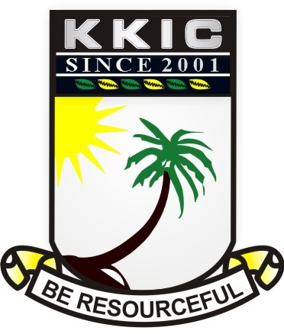

SURNAME |  |  | OTHER SURNAMES
SUBJECT | CIVIC EDUCATION | CLASS |  | JSS1 | DURATION | 1HOUR, 30 MINS.
INSTRUCTION: ANSWER ALL QUESTIONS FROM THIS SECTION
SECTION A-OBJECTIVE [20 MARKS

- The state of being aware and responsive to one’s surroundings is ---------
- consciousness
- alive
- sleeping
- playing

- ----------- is the feeling of love, devotion and attachment to one’s country
- Citizenship
- Patriotism
- Alien
- Nationality

- A mark or character used to represent an object or a function is referred to as ------
- characters
- language
- symbols
- pointers

- An example of the national symbol is ----------
- Traffic light
- Zebra crossing
- Pedestrian
- Coat of arm

- The armorial bearing is also known as the
- coat of many colours
- power house
- command
- coat of arm

- From the image below which of these cannot be found on the coat of
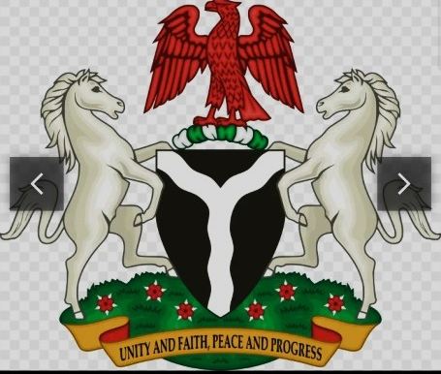
- horse
- eagle
- parrot
- black shield

- The motto on the coat of arm is unity and faith, peace and -----------
- power
- progress
- people
- pieces

- The fertile land of the country is represented by the ----------
- black shield
- Y-shaped
- two horses
- flowering plant

- The two horses on the image below represent ---------------
- peace and power
- unity and peace
- integrity and dignity
- fertile soil

- The point where the two rivers meet is called ------------
- meeting point
- joining point
- confluence
- center

- The flowering plant is also known as ----------------
- roses
- coctus spectabilis
- hibiscus
- yarn

- The Y-shaped silvery band represent river Niger and river -----------
- Nile
- Benue
- Lokoja
- Akwa-ibom

- The confluence is located at ----------
- Niger
- Minna
- Lokoja
- Abia

- The eagle depicts ----------
- integrity
- unity
- peace
- pride

- Which of these is not among the national symbols?
- The national anthem
- The coat of arms
- The national flag
- The Nigerian army

- The Nierian flag was designed by ------ in the year -----------
- Mike Taison, 1978
- Mike Tyson, 1959
- Michael Taiwo Akunyemi, 1959
- Michael Taiwo Akinkunmi 1959

- The Nigerian flag was hoisted on ---------
- October 1st, 1960
- October 1st, 1959
- October 1st. 1963
- January 1st, 1961

- The colour green on the national flag stands for agriculture while the colour white stands for peace and ----------
- Progress
- Justice
- Unity
- Power

- The old Nigeria anthem was composed by -------------
- Lillian Barch
- Benedict Odinaka
- Tim Godfrey
- Benedict Elise Odiase

- Arise O’ compatriot was adopted in the year -------------
- 1975
- 1976
- 1977
- 1978

- The first Nigeria anthem was written by --------------
- Lillian Jean Williams
- Anikulapo Fela Ransomkuti
- Sir Shina Peter
- African China

- The old Nigeria anthem has ------- stanza while the new one has -------- stanzas
- 3 and 4
- 2 and 3
- 23 and 2
- 2 and 4

- Nigeria may be blessed is last line in the ------------ stanza
- first
- second
- third
- fourth

- A statement of oath by the citizens to the Nigerian state is the -----------
- school anthem
- church pledge
- school pledge
- national pledge

- The national pledge was written by ---------- in the year -----------
- Felicia Adebola Adedoyin, 1976
- Felicia Natasha, 1976
- Patience Jonathan, 1975
- Stella Obasanjo, 1976

- The image below shows a team reciting the ---------
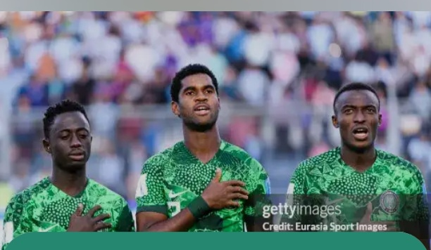
- national pledge
- national song
- school song
- church song

- The official medium of exchange in Nigeria is ----------
- pound
- dollars
- yen
- naira and kobo

- The highest currency in Nigeria is --------
- #100
- #200
- #500
- #1000

- Whose images are on the #1000 note?
- Dr. Nnamdi Azikiwe and Sir Ahmadu Bello
- Alhaji Aliyu Mai- Bornu and Clement Isong
- Sir Tafawa Balewa and Alvan Ikoku
- Bola Tinubu Ahmed and Babajide Olusola Sanwolu

- Dr. Nnamdi Azikiwe is on the ---------- naira note
- #100
- #200
- #500
- #1000

- Which of these is also known as international passport?
- The national identity card
- Voter’s card
- Tax ID
- The national passport

- All these are information on the national identity card EXCEPT -----------
- date of birth
- passport photograph
- residential address
- complexion

- The image below shows ---------
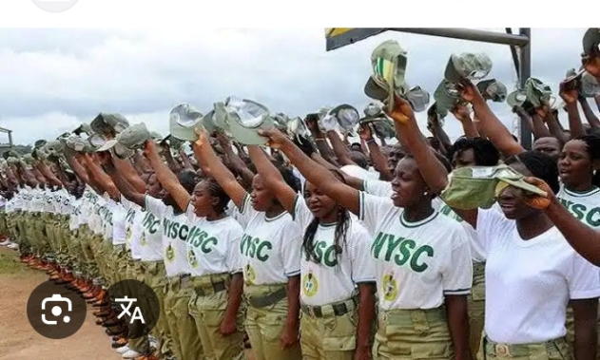
- a corp member
- a navy
- a police
- an army

- Which of these is not an establishment to promote national unity?
- Unity schools
- National festivals
- Nigerian Defense Academy
- Airports

- NYSC was established in the year ------------
- 1971
- 1972
- 1973
- 1974

- The full meaning of NYSC is -------------
- National Youth Service Corps
- Nigerian Youth Service Call
- Now Your Suffering Continues
- Nigeria Young Servants Corps

- All these are the purpose of the NYSC scheme EXCEPT
- To develop common ties among youths
- To promote indiscipline among youths
- To remove prejudice and ignorant
- To enable youths acquire the support of self-reliance

- One of these is a unity school
- Kith & kin International school
- Caleb International school
- Federal Government College
- Fountain Height school

- All these are national festivals EXCEPT
- National sport festivals
- Cultural and Art fesytivals
- Exhibition and Science Technology
- Olympic games

- One other way of promoting national unity is -----------
- non-discrimination of tribe
- getting a national identity card
- getting an international passport
- going to unity school

- One of these is not a way of promoting national unity
- Encouragement of inter-marriage
- Hospitality
- Tolerance
- Fighting

- The above picture is known as the --------
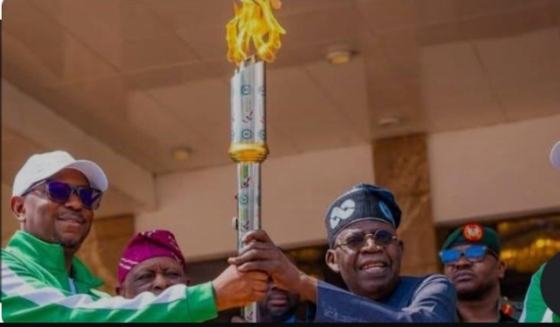
- Lamp
- Torch
- Mace
- Unity lamp

- A document that contains the rules and regulation that governs a country is known as the ----------
- handbook
- notepad
- map
- constitution

- Values include all EXCEPT
- hardwork
- discipline
- laziness
- integrity

- All these are sources of values EXCEPT
- food
- family
- community
- religious institution

- ---------- is the ability to do things by oneself without relying on other people
- honesty
- self-discipline
- self-reliant
- self-affection

- One of these is an attribute of self-reliance
- It promotes independence
- It does not help in development
- It does not promote self-confidence
- It does not help one to discover one’s talent

- ------- are obligations of citizens in a country
- Responses
- Duties
- Rights
- Associations

- ------ are claims of individuals as a citizen of a country
- Duties
- Responsibilities
- Rights
- Taxes

- Non-performance of citizens’ obligations can result to all EXCEPT
- chaos
- confusion
- violence
- peace

SECTION B: THEORY
INSTRUCTION: ANSWER FOUR QUESTIONS IN ALL IN THIS SECTION

- Define national symbol 2marks
1b. List eight national symbols 8marks

- Mention five objects on the coat of arm and what each symbolizes 5marks
2b. List five information contained on the national identity card 5marks

- Write the first stanza of the national anthem 5marks
3b. In a tabular form write the names of the Nigerian heroes on the following naira note
(i) #200 (ii) #100 (iii) #10 (iv) #20 (v) #50 5marks

- List four institution established by the government to promote national unity 4marks
4b. state three ways individuals can promote national unity 3marks
4c. Write the national pledge 3marks

- Define the following (i) honesty ii. dishonesty 2marks
5b. write four benefits of honesty and four punishments for dishonesty 8marks

- State three differences between a citizen and a non-citizen 3marks
6b. write three rights of a citizen and four duties of a citizen 7marks

